**Note on all tasks:**

* **Don’t worry about what systems Making Music has or doesn’t have; assume what you’d want to do is possible**
* **You can either fill in answers on the online form directly or you can upload a file if you prefer**

**Task one, page two:** You will need to answer the following question:

The graph shows the numbers of new vocal groups and instrumental groups joining Making Music membership over four years.

The table shows how new members found out about us over the same period.

Please outline what conclusions you would draw from this data and therefore what your recruitment marketing strategy might look like.

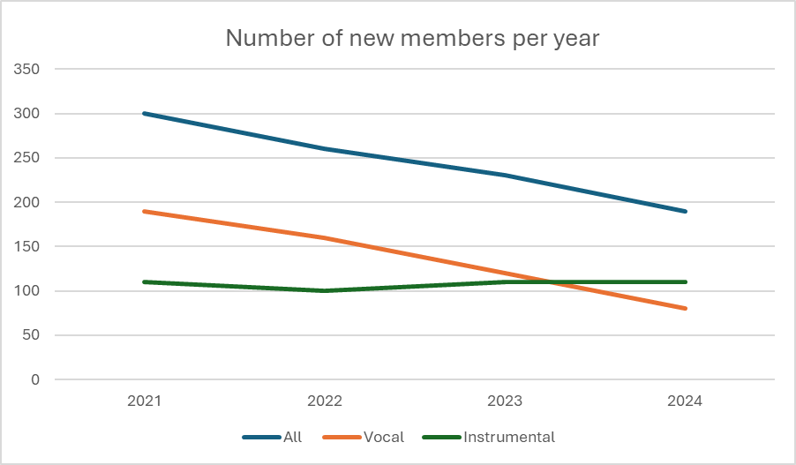

|  |  |  |  |  |
| --- | --- | --- | --- | --- |
| How did you find out about Making Music? | 2021 | 2022 | 2023 | 2024 |
| Word of mouth | 62% | 61% | 64% | 63% |
| Making Music website | 31% | 32% | 29% | 30% |
| Social media | 6% | 5% | 6% | 6% |
| Other | 1% | 2% | 1% | 1% |

(NOTE: data in both are not real!)

Max. 400 word count

**Task two, page three:** You will need to answer the following question:

You want to promote Making Music’s Charity Registration service to existing members and use it also to recruit new members, as this service is only available to Making Music members.

(Note: this service helps members to become officially registered with the Charity Commission, which they need to do if their constitution has charitable objectives and their annual income is above £5k. Members need help with ensuring their constitution is right for this and that they articulate the answers to the Charity Commission questions well. This is a separate paid for service. This service is delivered as part of our 5 year plan’s Aim 2 to support music groups to have robust governance.)

What platforms, media and tools might you use to reach members or potential members to encourage them to use the service?

Max. 200 word count

**Task three, page four:** You will need to answer the following question:

How would you go about researching what makes groups join – or not join – Making Music, and how would you use that research to create the key messages of a recruitment campaign?

Max. 300 word count